* VLANs: motivation
  + consider:
  + CS user moves office to EE, but wants connect to CS switch?
  + single broadcast domain:
    - • all layer-2 broadcast traffic (ARP, DHCP, unknown location of destination MAC address) must cross entire LAN
    - • security/privacy, efficiency issues
  + 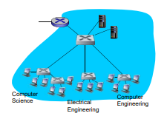
  + Virtual Local Area Network
    - switch(es) supporting VLAN capabilities can be configured to define multiple virtual LANS over single physical LAN infrastructure.
    - port-based VLAN: switch ports grouped (by switch management software) so that single physical switch …
    - 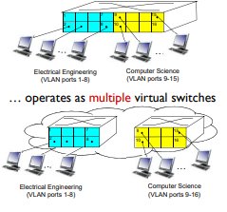
  + Port-based VLAN
    - traffic isolation: frames to/from ports 1-8 can only reach ports 1-8
      * • can also define VLAN based on MAC addresses of endpoints, rather than switch port
    - dynamic membership: ports can be dynamically assigned among VLANs
    - forwarding between VLANS: done via routing (just as with separate switches)
      * • in practice vendors sell combined switches plus routers
    - 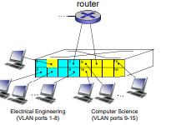
* VLANs spanning multiple switches
  + 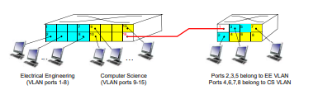
  + trunk port: carries frames between VLANS defined over multiple physical switches •
    - frames forwarded within VLAN between switches can’t be vanilla 802.1 frames (must carry VLAN ID info)
    - • 802.1q protocol adds/removed additional header fields for frames forwarded between trunk ports
* 802.1 Q VLAN frame format
  + 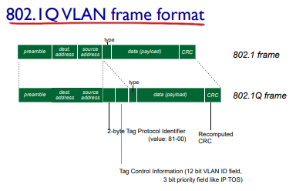
* Multiprotocol label switch (MPLS)
  + initial goal: high-speed IP forwarding using fixed length label (instead of IP address) • fast lookup using fixed length identifier (rather than shortest prefix matching) • borrowing ideas from Virtual Circuit (VC) approach • but IP datagram still keeps IP address!
  + 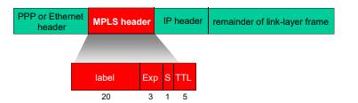
  + MPLS header:
    - Exp: experiment
    - S: stop
    - TTL:
  + Remainder of link-layer frame
    - Datagram
    - CRC
* MPLS capable routers
  + a.k.a. label-switched router
  + forward packets to outgoing interface based only on label value (don’t inspect IP address)
    - • MPLS forwarding table distinct from IP forwarding tables
  + flexibility: MPLS forwarding decisions can differ from those of IP
    - • use destination and source addresses to route flows to same destination differently (traffic engineering)
    - • re-route flows quickly if link fails: pre-computed backup paths (useful for VoIP)
* MPLS vs. IP Paths
  + IP routing: path to destination determined by destination address alone
  + 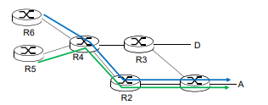
  + 
  + 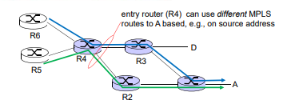
  + MPLS routing: path to destination can be based on source and destination address
    - • fast reroute: precompute backup routes in case of link failure
    - 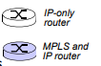
* MPLS Signaling
  + modify OSPF, IS-IS link-state flooding protocols to carry info used by MPLS routing,
    - • e.g., link bandwidth, amount of “reserved” link bandwidth D R4 R5 A R6
  + entry MPLS router uses RSVP-TE signaling protocol to set up MPLS forwarding at downstream routers
  + 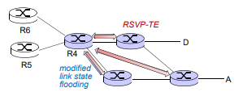
* MPLS Forwarding tables
  + 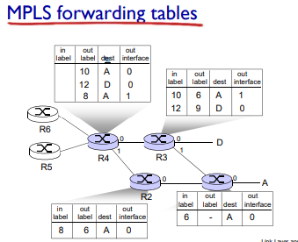
* Data Center Network
  + 10’s to 100’s of thousands of hosts, often closely coupled, in close proximity:
    - • e-business (e.g. Amazon)
    - • content-servers (e.g., YouTube, Akamai, Apple, Microsoft)
    - • search engines, data mining (e.g., Google)
  + challenges:
    - multiple applications, each serving massive numbers of clients
    - managing/balancing load, avoiding processing, networking, data bottlenecks
  + load balancer: application-layer routing
    - receives external client requests
    - directs workload within data center
    - returns results to external client (hiding data center internals from client)
    - 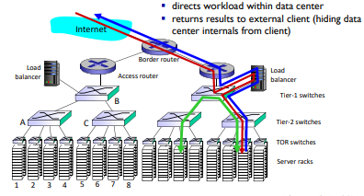
  + rich interconnection among switches, racks:
    - • increased throughput between racks (multiple routing paths possible)
    - • increased reliability via redundancy
    - 